MISSIONARIES AND CANNIBALS PROBLEM
Aim
To solve the Missionaries and Cannibals problem using Artificial Intelligence search techniques.
Objectives
- To understand state-space search.
- To transport all missionaries and cannibals safely.
- To ensure missionaries are never outnumbered.
- To find a valid sequence of moves.
Algorithm
- Start.
- Initialize the starting state (3,3,1).
- Generate all possible valid moves.
- Check whether the move is safe.
- If safe, move missionaries and/or cannibals.
- Repeat until the goal state (0,0,0) is reached.
- Display the solution path.
- Stop.

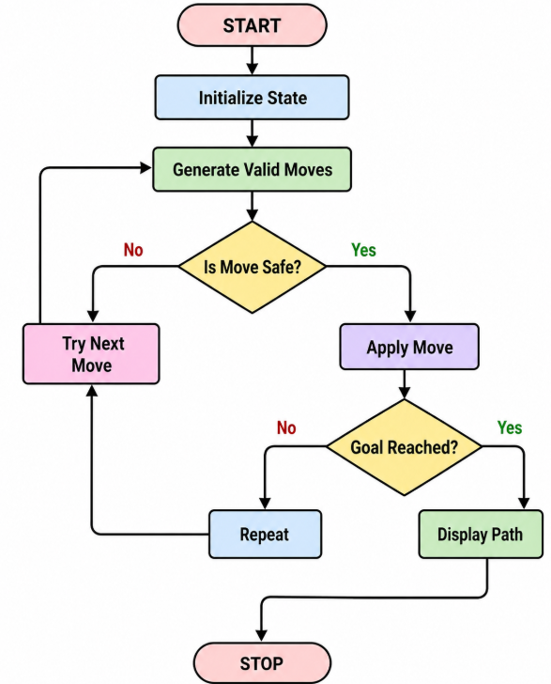
PROGRAM
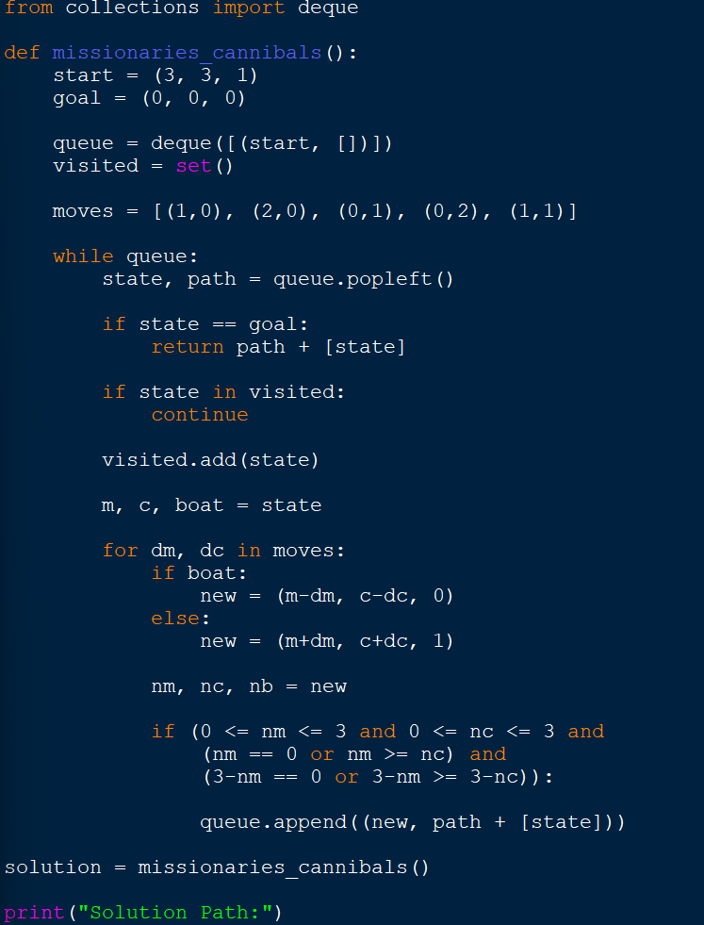

OUTPUT

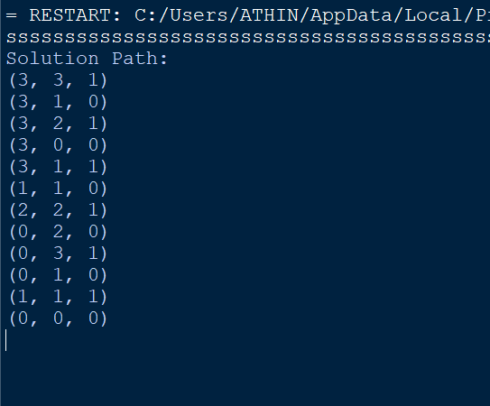

Result
The Missionaries and Cannibals problem was successfully solved using the Breadth First Search (BFS) algorithm, and all missionaries and cannibals were transported safely to the opposite bank.

